Purpose
The purpose of this document is to:
- Capture the background and current problem statement with regards traffic management through Garsdale Parish,
- Review and present the options for traffic calming measures using additional signage which have been considered,
- Provide recommended options with the supporting rationale to Garsdale Parish Council, so that the council can consider these, agree next steps and any associated actions required.

Contents
1. Purpose 1
2. Background 1
3. Problem Statement 2
4. Required Outcome 3
5. Risks to be considered. 3
6. Recommended Option 3
7: Signage Costs 4
7.1 Cost of general hazard signs 5
8. Options and potential costs 6
Option 1 Entry & Exit Signs at the Parish Boundaries 6
1a. Suggested Signage Wording for the Parish Boundary locations 6
Option 2: Entry & Exit Signs at the Parish Boundaries and at the start and end of the “Village” 7
2a. Suggested Signage Wording for the Parish Boundary and “village” locations 7
Option 3: Hybrid Shared post mounted Entry & Exit Signs at the Parish Boundaries supplemented by a number of additional hazard signs within the Parish. 7
Option 4: Hazard Signs Only 8
8. Potential locations of additional signage within Garsdale Parish 10
8.1 Boundary signage potential locations 10
8.2 Hazard sign potential locations 12

Background
Garsdale is a relatively small dale, which sits within the Yorkshire Dales National Park. Garsdale parish has a population of approximately 197 residents, most of whom live on or within close vicinity of the A684 from Sedbergh towards Hawes.
The A684 through Garsdale parish is a mixture of 60mph National Speed Limit with 30mph limits around some of the tighter or narrower bends, as well as through Garsdale village itself.
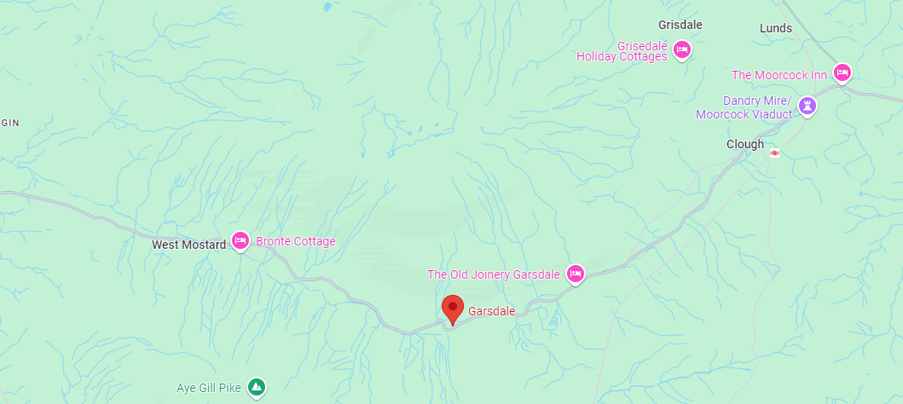
Being within the beautiful Yorkshire Dales National Park Garsdale naturally attracts a number of passing tourists which particularly during holiday season or warmer/drier weather increases the traffic and associated noise along the A684.

Problem Statement
A small number of local residents have raised concerns to the Parish Council (PC) in relation to the traffic on the A684.
It is not yet clear if the issues are specifically relating to all traffic or specifically motorcyclists, noting that there is an increase in the number of motorcycles during the warmer drier weather, but also that there are often groups of cars which also frequent the dale.
Issues could include:
- The volume of motorcyclists,
- The speed of motorcyclists,
- The environmental impact / noise generated by motorcyclists,
Or
- The volume of overall traffic,
- The speed of overall traffic,
- The environmental impact / noise generated by overall traffic.
For the purpose of this paper, it is assumed that the problem is related to overall traffic, particularly speed, however Option 4, to introduce a number of plausible Hazard Signs throughout the parish could potentially be an effective way of reducing the speed of traffic, and particularly motorcyclists.
At the Parish Council meeting held on 18th July 2024, it was stated that speed at key points through the parish had been monitored and overall, most motorists were compliant with the speed limits. It was also stated that the PC had a small amount of funds available, and that they might consider allocating some of this to implement supplementary traffic calming measures, specifically additional signage through the parish, if it was feasibility to do so.

Required Outcome
For the PC to agree a consensus and next steps, regarding the potential implementation of local traffic calming measures within the parish.

Risks to be considered.
The A684 is a National Highway and as such it is important to consider potential risks when erecting signage on the side of the highway, or in close proximity to the signage. Risks could include:
- Distraction to motorists
- Harm caused to motorists by the presence and type of signage in the event of an incident or accident.
In order to mitigate these risks, it is recommended that:
- Signage should be avoided in areas of higher risk, ie, sharp bends, blind spots etc, in order to reduce the potential distraction to motorists.
- Signage should not be positioned within 100m of an existing Hazard Sign, in order to reduce the potential distraction to motorists.
- Where possible signage should be positioned as far away from the highway as possible, whilst still being visible to motorists.
- The design (colour/shape) of any signage should not align to National Highway Signage which has a dedicated meaning. For example, blue signs should be avoided as these are Motorway signs etc.

Recommended Option

Having reviewed the options, it is not believed that placing “Welcome to Garsdale please Drive Safely” on entry to the Parish and / or “Thankyou for driving safely” on exit from the Parish would deliver much benefit and is a relatively expensive option which may not work.
Therefore, the recommended approach is to consider introducing a small number of localised hazard signs, where natural hazards exist, focusing around specific areas where local residents have raised concerns in relation to traffic.
It is believed that this is not only a more cost-effective option, but also one which has the potential for greater impact.

7: Signage Costs
There are a number of companies that supply road signs which allow free text and are available in different sizes and shapes and colours.
Road Signs Direct https://roadsignsdirect.co.uk & Safety Signs 4 Less https://www.safetysigns4less.co.uk are two companies which were reviewed in order to provide a price comparison.
Company | Free Text | Size (m) | Material | Thickness (mm) | Anti-Graffiti Coating | Life Expectancy (Years) | Fixings if Applicable | Sign £  (Ex VAT) | Sign £  (Inc VAT) | Post & Fixings £ (Ex VAT) | Post & Fixings £  (Inc VAT) | Wall Fixing £ (Ex VAT) | Wall Fixing £ (Inc VAT)
Safety Signs 4 Less | Y | 1 x 0.67 | Reflective Aluminium Composite | 3 | N | 7 | N/a | £74.93 | £89.92 | £95 | £114 | £3.96 | £4.75
Road Signs Direct | Y | 0.6 x 0.45 | Composite Aluminium Substrate | 3 | N | 12 | Wall Mounted | £66 | £79.20 | N/a | N/a | N/a | N/a
Road Signs Direct | Y | 0.6 x 0.45 | Composite Aluminium Substrate | 3 | N | 12 | Rail & Post Clips Included | £74 | £88.80 | Approx £52 for 2 | Approx £62.40 for 2 | N/a | N/a
Road Signs Direct | Y | 1 x 0.3 | Composite Aluminium Substrate | 3 | N | 12 | Wall Mounted | £72 | £86.40 | N/a | N/a | N/a | N/a
Road Signs Direct | Y | 1 x 0.3 | Composite Aluminium Substrate | 3 | N | 12 | Rail & Post Clips Included | £80 | £96 | Approx £52 for 2 | Approx £62.40 for 2 | N/a | N/a
Road Signs Direct | Y | 1.05 x 0.75 | Composite Aluminium Substrate | 3 | N | 12 | Wall Mounted | £159.80 | £191.76 | N/a | N/a | N/a | N/a
Road Signs Direct | Y | 1.05 x 0.75 | Composite Aluminium Substrate | 3 | N | 12 | Rail & Post Clips Included | £177.50 | £213 | Approx £52 for 2 | Approx £62.40 for 2 | N/a | N/a

Note: Roads Signs Direct sell a bundle of 20 fully galvanised x 76mm diameter posts for £432 excluding VAT.
Of the above costs, the Red items have been discarded as relatively expensive (and large).

The average costs of wall mounted signs v post mounted signs (per unit assuming two posts per sign) are below.
Company | Sign Only | 2 Posts only | Sign & Full Fixings £  (Inc VAT)
Average Wall Mounted Sign Cost | N/a | N/a | £81.76
Average Post Mounted Sign Cost | £91.58 | £88.20 | £171.17

These averages have been used to consider the options and potential cost to the Parish.

7.1 Cost of general hazard signs

The costs of general hazard signs Is much lower than the larger rectangular signage. These can be purchased for approximately £25 to £40 excluding VAT. (£30 - £48 including VAT).
Examples include:
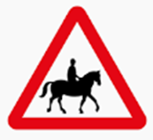
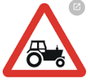
The cost of a post is approximately £31.20 including VAT therefore the estimated overall cost of a single direction hazard sign is approximately £70.20 including VAT and excluding labour and materials to fit the sign.
If the location warranted a bi-directional sign this would bring the cost for a single location to £109.20 including VAT and excluding labour and materials to fit the sign.

8. Options and potential costs
It has been expressed that the Parish Council would like to consider entry and exit signs:
- Welcoming people to Garsdale and asking them to drive safely and
- Thanking them for driving safely
It is noted that at the Richmondshire Border in the East of the Parish boundary that the country entry and exit signs are on the same side of the road (see below). If this approach was adopted at the Parish boundaries this would aid keeping the overall costs down as the posts could be shared by the two signs.
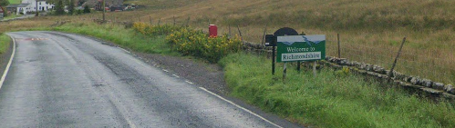
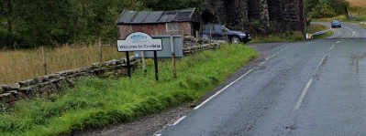

Option 1 Entry & Exit Signs at the Parish Boundaries
The estimated cost of this option with shared post mounted signs located in the vicinity of the Parish Boundaries only would be approximately £542.72 including VAT.
This cost does NOT include the labour and materials to fit the posts.
Note: The costs could be reduced to approximately £327.04 including VAT if there was an appropriate wall to fix the signage to (and permission granted of course)

1a. Suggested Signage Wording for the Parish Boundary locations
Potentially the wording on the entry and exit signs could be along the lines of:
- On Entry - Welcome to Garsdale Parish, please drive carefully.
- On Exit – Thank you for driving carefully.
There is a potential issue with this option. Garsdale Parish is quite rural and other than through “the village” which already has a Garsdale sign, there isn’t really a cluster of population. With that in mind, what would be the impact of these signs? If a motorist past it and acknowledged the message to please drive carefully but then didn’t past any homes or clusters of homes for quite some time, could they potentially think “so what”?

Option 2: Entry & Exit Signs at the Parish Boundaries and at the start and end of the “Village”
The estimated cost of this option with shared post mounted signs located in the vicinity of the Parish Boundaries AND on entry and exist to “the Village” would be £1085.44 including VAT.
This cost does NOT include the labour and materials to fit the posts.
Note: The costs could be reduced to approximately £490.56 including VAT if there was an appropriate wall to fix the signage to (and permission granted of course)

2a. Suggested Signage Wording for the Parish Boundary and “village” locations
As per option 1 above, the wording of the signage could be along the lines of:
- On Entry - Welcome to Garsdale Parish, please drive carefully.
- On Exit – Thank you for driving carefully.
This still generates the same potential issue as Option 1.

Option 3: Hybrid Signage
The average cost of a bespoke hazard sign is much lower, therefore, if the PC were to consider a hybrid option with entry and exit signs at the Parish Boundary supplemented by two hazard signs on entry to “the village” in both directions, and with potentially an additional 2 hazard signs positioned in other traffic hot spots this could take the estimated cost of this option to £823.52 including VAT and excluding labour and materials to fit the sign.

Option 4: Hazard Signs Only
This option moves slightly away from the discussion at the PC meeting held on 18th July 2024, in so much that it does not factor in entry and exit signs into the parish or the village.
Instead, this option is to consider strategically placing plausible hazard signs along the Garsdale Parish area of the A684, particularly around locations where issues have been raised in relation to traffic.
Motorcyclists are potentially at a higher risk of personal injury than many other forms of motorist. As a result, it could be stated that most motorcyclists are extra vigilant to hazards and things which could potentially cause them harm.
If one of the primary concerns is motorcyclists, by introducing realistic hazard signs this could potentially be used to reduce the speed of them and potentially other motorised vehicles.
However, it should be noted that a motorbike often generates more noise when slowing down or speeding up, than it does when riding at a constant speed.
Plausible Hazard Signs which could be considered within Garsdale include:
- Tractors Turning
- Accompanied Horses in Road

- Sheep in the Road
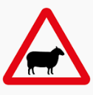
- Mud on the road
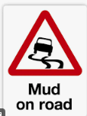
- Debris on the road / Loose Gravel
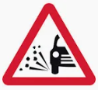
The estimated cost of a single direction hazard sign and post is approximately £70.20 including VAT (not including materials or costs to install).
The cost of a bi-directional hazard sign is estimated as being £109.20 including VAT (not including materials or costs to install).
Therefore, there is the opportunity with this option to cover a larger number of specific areas within the parish, ie either 10 locations with single direction signage or if bi-directional signage was required approximately 8 locations.

Potential locations of additional signage within Garsdale Parish

Boundary signage potential locations
Potential locations for the Parish Boundary signage are below.
At the East End of the Parish, the signage could be slightly west of the current Cumbria/Richmondshire boundary and at the West side of Railway Bridge on the approach to the Hawes Junction Methodist Chapel
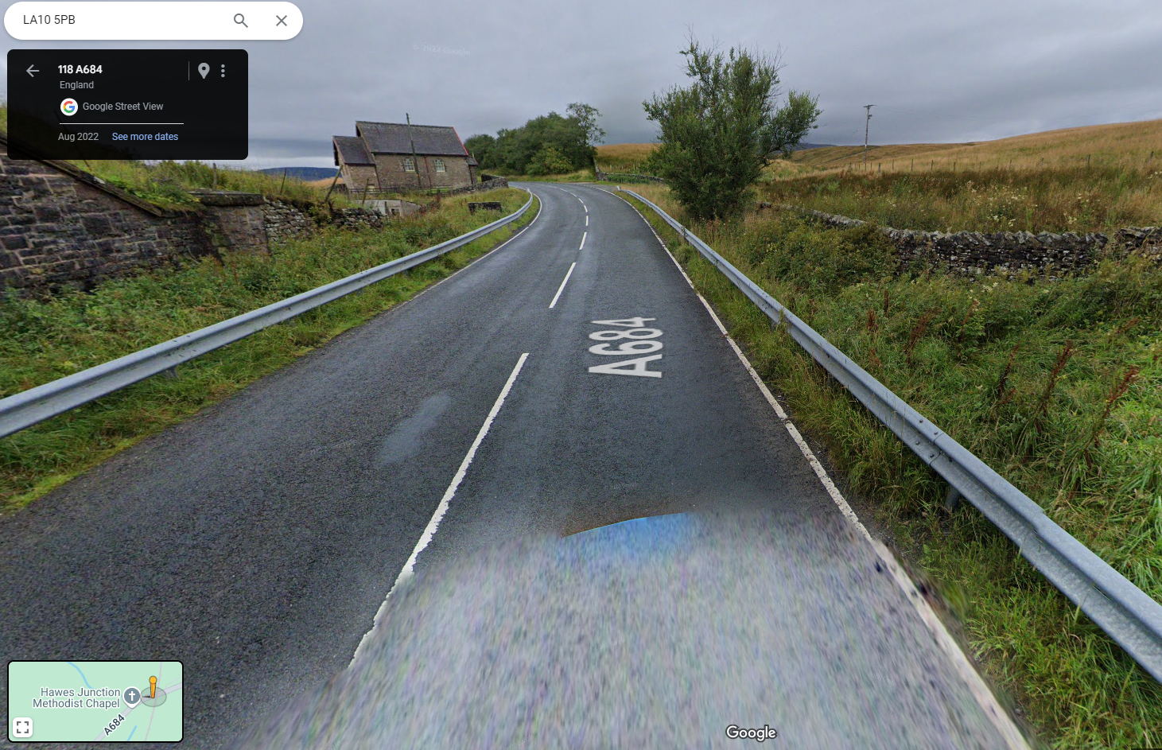
However, it should be noted that there are very few residential properties for the following mile or so and the road is made up of gentle curves which naturally allow driving towards the top end of the speed limit of 60mph.
Would this actually have any impact?

At the West End of the Parish, the signage could be slightly west of the cattle grid on the approach to the first buildings however the grass verge there is extremely narrow. Therefore, this is not practicable unless permission was sought from the adjacent landowner to have a post in their field or attach a sign to the barn which would only satisfy the “entry into Garsdale” element.
The road is also very narrow here and there is already a hazard warning sign through this section of the dale, so again would this actually have any impact.
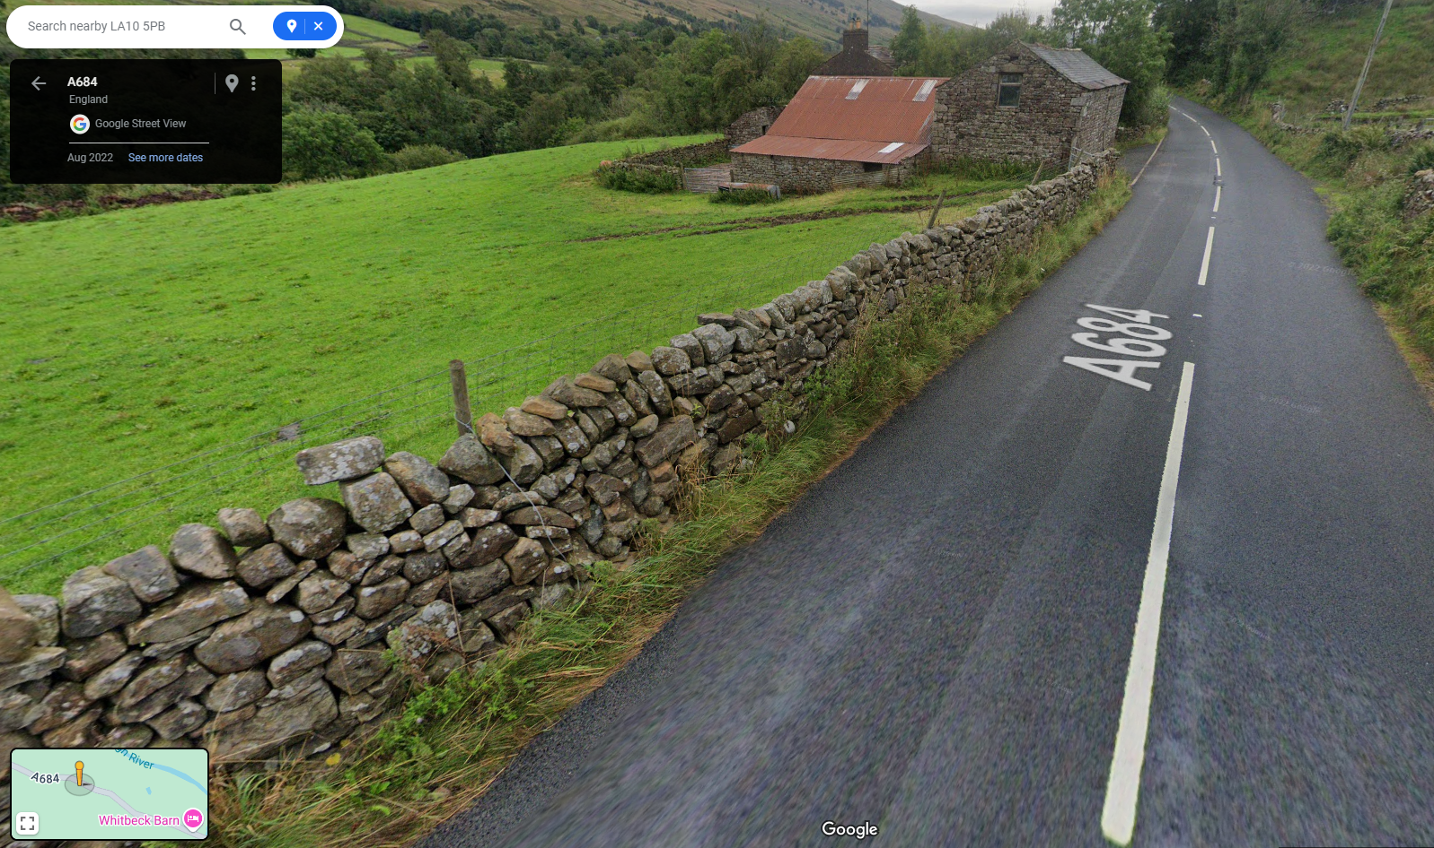
An alternative for the East End of the Parish would be to position slightly further east, on the approach to Mary Wood’s house and the chicken farm. There is a slightly wider verge there as well.
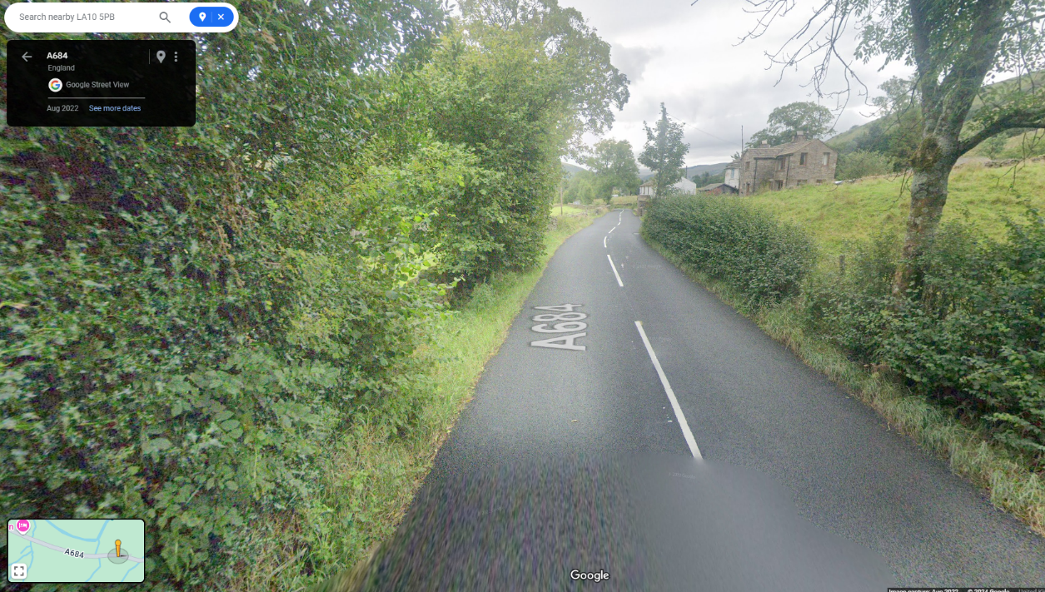

Hazard sign potential locations
Garsdale Parish has some natural things which create Hazards. Below are some examples of the types of natural hazards in this environment that could be used to potentially slow down traffic.
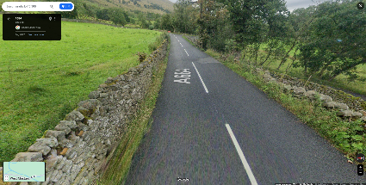
Road Liable to Flooding near D&R Labbate.
Horse & Rider to the west of the Village
Chickens on the road East of the village (Someone may need to buy chickens)
Sheep on the road between Nev & Russell (often is)
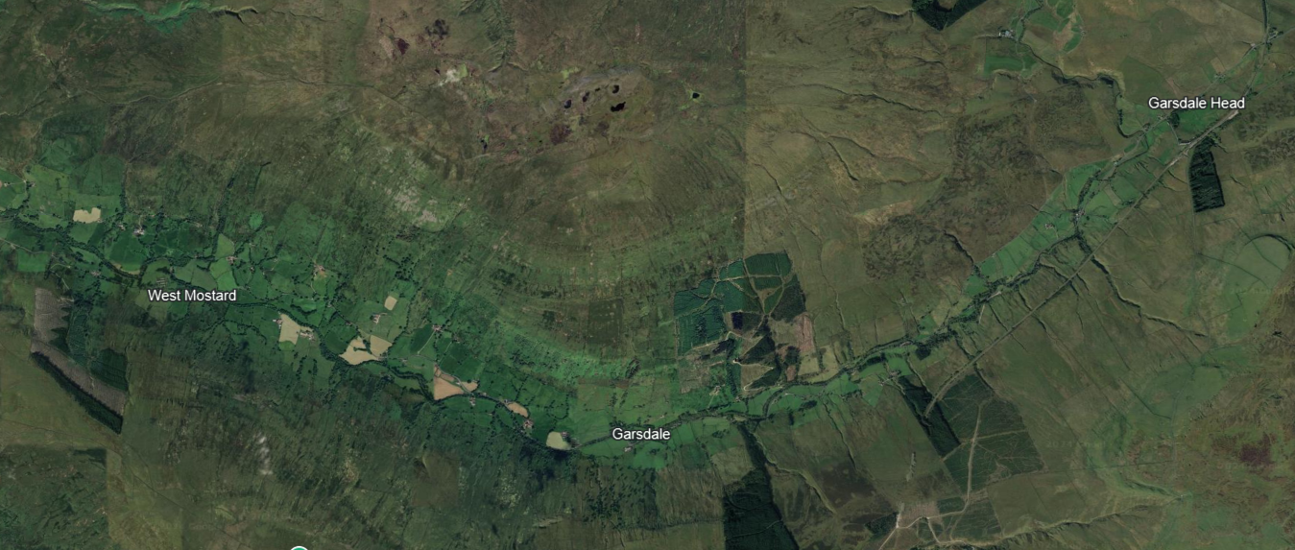
Low House – Tractors Turning or Mud on Road

